Project Documentation

Sahithi Eluri(G01399786)

**1.Introduction:**

This documentation describes developing and implementing a full-stack application designed to allow prospective students to submit and view all recorded surveys. The project entails developing a frontend with Angular (version 16.1.8) and a backend with RESTful Web Services and JPA on the Spring Boot platform.

**2.Overview of the Project:**

The following features are available through the application:

* Homepage: Information about GMU's is available on the homepage of the CS Department. The Department of Computer Science. Two links are provided to the Student Survey form and Pages from the Survey List.
* Survey Form: This form enables potential students to provide input.
* Survey List: Displays all details who have submitted the survey form.

**3.Frontend (Angular):**

3.1Tools and Technologies Used

* Angular (version 16.1.8)
* Visual Studio Code
* IntelliJ Idea
* HTML
* CSS
* TypeScript
* Bootstrap

Angular code Front End: The following screenshots depicts the front-end angular application for Student Survey Form. After running the angular as “ng serve”, angular line development server is listening on loackhost:4200.

**4.spring boot(backend)**

**4.1 Tools and Technologies Used**

* Maven
* Spring Boot
* RESTful Web Services
* Spring Data JPA
* Database (MySQL Workbench)

In the backend we will connect the spring boot to MySQL with the help of JDBC server. So after running the backend code the spring boot will host the 8080 with tomcat server which we can seen in below screenshot.

**5.execution of the project:**

After running the Angular we can see in the screenshot its provide the localhost url, so we just follows the link which will open homepage in server.

3.In the Homepage there would be a 2 link which are surveyform page and list of submitted surveyform. We can see in the below screemshot

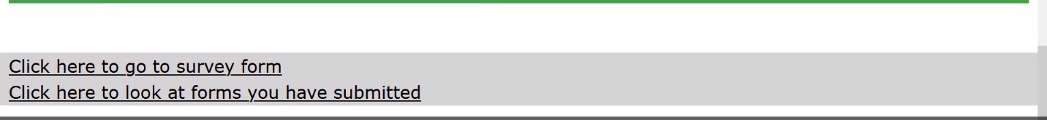

4.now we will click on the survey form to fill the form we can view on below screenshot

So after submitting the form it will store in backend. now we will click on the surveyform list link where we can see the details of the student which are submitted the form

